Main Street Musing

FIRST CONGREGATIONAL CHURCH OF SOUTH WINDSOR

February 2020

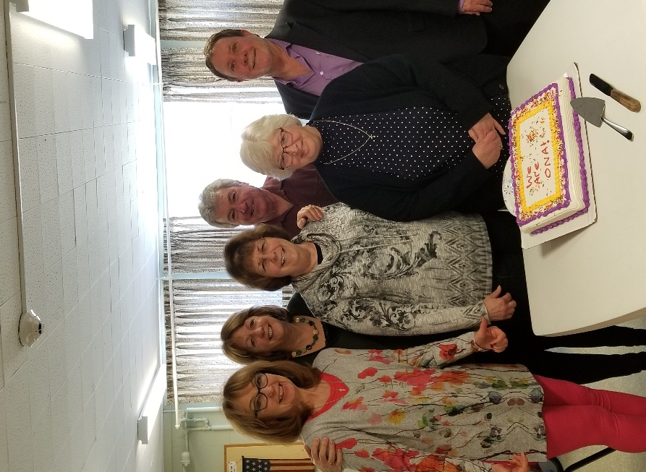

**INSIDE THIS ISSUE**

Pastor’s Letter 2

Book Group 3

Kamilla’s Kolumn 4

UCW 4

Holiday Fair Update 4

Mission News 5

Church School News 5

Lunch Bunch 5

Sewin4Servicemen 6

Historian’s Column 7-8

2020 Flower Chart 8

Coffee Hour Hosts 8

Food Ingathering 8

Church Family News 9

Deadlines & Details 10

**SAVE THE DATE**

Karin Ziel, Minister of Faith Formation/Guest Preacher/Safe Church Second Hour 02/09

Committee Night 02/11

Sewin4Service……….02/22Fellowship Hall 10am-4pm.

Int. Reg. Conf. Min. Chuck Erickson /Guest Preacher/Gov. Models Second Hour 02/23

Lent Begins: Ash Wednesday Service; 6:30pm Followed by Fat Tuesday Meal 02/26

WE ARE an OPEN and AFFIRMING CHURCH! CONGRATULATIONS TO ALL!

THANK YOU, ONA COMMITTEE FOR ALL YOUR HARD WORK: Nancy Stearns/Terry Belknap, Co-Chairs; Jim Belknap, Rick Whitin, Sheila McIntosh.

Well Done! Thanks be to God!

The vote took place at the January 26, 2020 Annual Meeting.

Friends,

Whew! It’s hard to believe January has passed already. What a great way to begin 2020 by becoming an Open and Affirming church!

This month, we have two guests who will be providing information pertinent to our by-laws revisions and governance model explorations. Sunday, February 9th, Karen Ziel, Minister of Faith Formation and Leadership for the Southern New England Conference, United Church of Christ (SNEC/UCC) will be our guest preacher. Worship will be followed by a ‘second-hour’ regarding the expansion of our Safe Church Policy. On Sunday, February 23rd, the Rev. Chuck Ericson, Interim Regional Conference Minister, also of the SNEUCC/UCC, will bring us up to date on our newly formed conference shared with the states of MA and RI. In addition, he will speak to us afterwards about governance models for small churches. Lunch will be served both days.

Ash Wednesday, is February 26 when we begin our pilgrimage to the cross and our Easter hope, through themed Sunday worship and devotionals chosen specifically for reflection during the Lenten season. An intimate service will be held in the Chapel at 6:30, then down we go to Fellowship hall for a modified, ‘Fat Wednesday’ pancake supper.

Then, it will be time for our Lenten Soup/Supper Series titled, “How Do We Talk To Each Other?” held on Wednesday evenings at 6:30 p.m., March 4, 11, 18, 25 and April 1. The compendium of speakers and presentations will focus on ways to engage with strangers – “no matter who they or where they are on life’s journey.” The hope is that education can dispel our discomfort in situations we aren’t used to, honoring the Christ and humanity in each other as we ‘draw the circle wider.’

Like the song in the musical “Bye, Bye Birdie” that says “We’ve got a lot of livin’ to do,” we’ve got a lot of ‘learnin’ to do! Please join us!

In Grace and Peace,

Rev. Nina

***Book Group***

Pastor Nina is excited to introduce “Witness For My Father” as the February 19th selection, and hopefully to all for a congregational read in the future. The author, Barbara Bergren, is from South Windsor. Barbara and Nina met on Nina’s trip to Israel in 2018. Ms. Bergren has agreed to speak at the church in the future about the book. This intensely personal and miraculous story of the depths and heights of humanity grips you and won’t let you go from cover to cover, and beyond. Book Group will meet on Wednesday, February 19th at noon in the Chapel.

“*Witness for my Father is a must-read story of survival and the love of family. Barbara Bergren’s extraordinary tribute to her father provides a vivid and disturbing picture of the plight of Jews in Europe during the Holocaust and recounts a remarkable and inspiring account of hope from unexpected heroes at the conclusion of the war.” –* [*www.barbarabergren.com*](http://www.barbarabergren.com)



|  |
| --- |
| **The very best valentine** |
| Almost everyone — at least of the female persuasion — knows the romantic meaning of the phrase “hearts and flowers.” Valentine’s Day is coming! What will I get from my boyfriend … my husband … my best friend? I’m hoping for some sort of bouquet, a card full of loving words and red hearts, candy or at least a sweet balloon.  Human beings may disappoint. That special someone may forget to check the calendar for February 14. But even if he doesn’t come through exactly as I hope, I can still be amazed and happy with the valentine I am sure to receive every day from my heavenly Father and his Son: words of delight and joy and caring — always surrounding me with love and more love. These are the best “hearts and flowers” I could ever have, and which I do have, on Valentine’s Day and throughout eternity.  —Sandy Hyland |

***Kamilla’s Kolumn***

Kamilla Mammedova

Happy New Year to all of you! What a year we have had again! Thanks goes to all of you - choir members, guest artists, harpist D.Vinick, and trumpeter, R.Chirico for bringing their talents to our Church. It was another wonderful collaboration with them.

And, of course, we appreciate Pastor Nina, all our staff and all of you in our Congregation, for supporting us, appreciating our music and praising our talents!

Hopefully, we will have another musically adventurous and joyfully fulfilling year ahead!

And, of course, a moment to joke with all of you and to brighten your day:

Four tenors and a baritone are hiking in the Alps, all roped together in a line.

Suddenly, they fall into a crevasse.

The baritone realizes the rope can't hold all five of them, so he yells down at the group, "There's so many baritones in the world and so few tenors. So, I'll sacrifice myself to save all of your lives."

All of the tenors started clapping and fell to their deaths.

***UCW News***

Ingrid Fraize

The United Church Women will be having a membership meeting on Sunday, February 2nd in Fellowship Hall following worship. There will be handouts of the bylaws and some other UCW business on the agenda to discuss. We hope to see you there!

***Holiday Fair Update***

Linda Dalpe and Jean Trotman

Our 2019 Heritage Holiday Fair was a great success, yielding a net profit of $9,711.60. This is a great testament to all who have worked on putting together this historical and annual event and particularly because we are such a small but amazing group. Thank you to all who contributed to make this a fun and successful tradition.

***Mission News***

Nancy Stearns, Rachel Anderson, and Marilyn Senger

The missions committee would like to thank all who helped with our Christmas gifts to Interval House in Hartford. This year we were able to present them with 25 pairs of women’s pajamas, over 200 pairs of underwear for women and children, 58 pairs of socks and around $600 in gift cards. This is all greatly appreciated by the Interval House staff and those who need their services.  
Our Christmas tree is now a warmth tree and during the month of January, we will collect hats, gloves and socks for the homeless in Hartford for the Reverend Bryan Bywater of the Street Church in Hartford. Again, many thanks for supporting this and all our mission’s efforts.

***Church School News***

Vicky Margiott

The Sunday School children have been busy at the start of the new year.  The children voted that the money from their mite boxes would support FIDELCO guide dogs.  We tied this outreach to our scripture lesson where Jesus healed and helped people.  The congregation can help with this mission as well.  There is a beautifully decorated box in the lower hall for gently used or new towels for the guide dogs to go along with our donations.

Over the past year and a half, the church school has been focusing on some of the key bible teachings.  Now that we have finished up our core lessons, there is a new curriculum that we are trying this Spring.  The teachers are excited to have more resources available to support the lessons.   The lessons through Lent focus on the life of Jesus and what attributes make a good leader.

Jean Jackson continues to teach songs to the children so you can look forward to future worship service participation.

***Lunch Bunch***

The lunch bunch meets September to June on the third Thursday of the month at 11:30 a.m. See you on February 20th.

***Sewin4Servicemen***

Judy Borré

7th Annual *Sewin4Servicemen*

Quilters Stitchers Crafters

HELP US HELP THEM

Join us to stitch Lap Quilts for our Veterans

Jan. 25, Feb. 22, Mar. 28 and Apr. 25, 2020

10 am to 4 pm

**First Congregational Church, UCC**

993 Main Street, South Windsor, CT

**Quilt size approximately 36 X 48 (for wheelchair)**

**Fabric and beverages will be provided.**

**Bring your sewing machine with wound bobbins & a brown bag lunch**

For information or to register contact Judy Borré @ (860) 528-7992 (church)

or Firstchurchsw@gmail.com

***Historian’s Column***

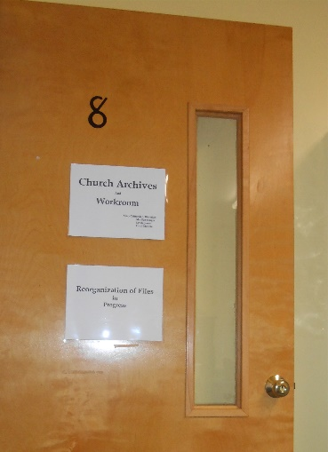Mary Crittenden

We have looked at the five windows that were dedicated on Oct. 5, 1903. We will return for the last two in coming months. This time around, I want to let you know about some of the work that is being done and work that is waiting for volunteers.

Update on progress in organizing, cataloging and filing the many cartons of materials we received this year.

Marilyn Senger continues to work with me on the photos one day a week – still handling photos from back log and new ones that are current.

The Archive Room is located on the 2nd floor of the Wolcott Memorial Chapel.

Lynda Jones and Carol Mattera have worked about three times per month on filing materials. Several cartons have been processed.

Eric Soares has been working to convert VCR tapes.

Others have stopped by while we are working. They have offered information, encouragement, and at times brought additional material.

During the months since the many cartons of files and papers were brought in to us, two vertical filing cabinets were donated by Linda Dalpe, and John and Jill Phillips. Bob and Tim Starr muscled our two bookcases up to the archive room.

We do have work that is waiting for volunteer workers. If you have questions about any of these or want to volunteer to help with these, please talk to me.

* Filing Sunday Bulletins, Annual Reports, and Newsletters. We are down to having half a carton of these as well as trying to keep up with the new ones.
* Writing a couple paragraphs about each object in our archive Memorial Cabinet in anticipation of publishing them in a booklet as a guide to our collection.
* Adding names below photos in our albums.
* Help with cataloging materials being put into our document boxes.
* Viewing our slides, organizing them, and selecting those that should be converted to digital pictures.
* Organizing and shelving recordings of Sunday Services.
* Help assess condition of our bound records as we catalog them. We need to consider how to preserve them and the first step is assessment.

A Special Request: Are you replacing a computer-- either a desk top or laptop? If so, would you like to donate the old one? The workers in the archive room would like to have one with Windows 10 and Excel. We want to create a catalog of our archival materials as we file them and are finding the old church laptop with Vista to be a challenge.



***2020 Flower Chart***

The 2020 Flower Chart is posted on the bulletin board in Fellowship Hall. Individuals and families are welcome to sign up to provide flowers. Please note how the acknowledgement is to be made. Donors are responsible for ordering and arranging for flowers to be in church on Sunday. Donors may take their arrangements home following service or deliver them to one of our homebound members and friends.

***Coffee Hour Hosts Needed***

Please check your calendar for when you are able to host. The calendar for Coffee Hour Hosts for 2020 is posted on the bulletin board by the kitchen window. If you have not hosted before, but would like to host and need some guidance, please feel free to ask one of the “regulars” to mentor you.

***Food Ingathering***

This month, our food ingathering collection will be Sunday, Feb. 9th. These items are distributed to the South Windsor Food and Fuel Bank. Any donations are greatly appreciated.

***Church Family News***

Please keep Leilani and Merle Dinse in your thoughts and prayers as they grieve the loss of Leilani’s son, Vincent DeMaio, who passed away on December 28, 2019.



Kristen Daigle 02/03

Nancy Stearns 02/06

Amanda McNulty 02/09

Caitlin Connelly 02/11

Caroline Klein 02/12

Samantha McNulty 02/12

Cliff McClellan 02/13

Emaleigh Daigle 02/14

Marilyn Senger 02/15

Clayton Daigle 02/18

Beverly Zaugg 02/21

Ruth Bombara 02/22



Joyce Coon

Bev Neilsen

Doris Burgdorf

Jim Jackson

Dave Chapman

Merle & Leilani Dinse

Shirley Lawton

Vibert Deane

Avis Pelletier

Beverly Devren Stewart

Melody Treadwell

Michael Bombara



Send them a note today!

|  |  |
| --- | --- |
| Bev Nielsen  58 Pleasant Valley Road  South Windsor, CT 06074 | Joyce Coon Arbors at Hopbrook  403 W Center Street; Apt. 316 Manchester, CT 06040 |

***Newsletter Deadline***

The deadline for the next newsletter is **Saturday, February 15th.** It will be printed on February 27th. Let’s get everyone caught up on what is happening in the church.

***Weekly Announcements Deadline***

The deadline for the weekly bulletin announcements will be Wednesdays at noon. You may send any announcements electronically or put in the Administrative Assistant’s mailbox.

***How do you want to receive the Newsletter?***

If you would like to receive the *Main Street Musing* via email, please email the church office at firstchurchsw@gmail.com. This will help in production and mailing costs. Thank you. As an added bonus, you will see the graphics in color.

***Office Hours***

Office hours will be Tuesday – Friday 9am – 2pm, unless otherwise noted.

***Weather Cancellations***

WORSHIP SERVICE AND EVENT CANCELLATIONS

If the weather is threatening, you can check for cancellation notices of our events, including Sunday morning worship service and church school, by watching WFSB TV (CBS-Channel) or listening to WTIC (1080 AM). Notices are also posted on both the websites for WFSB news and the WTIC Storm Center. Generally, a decision to cancel worship will be made on Sunday morning around 7 a.m. Every effort will be made to update the church answering machine and send out an email-blast. If you know of anyone who does not use email, please share the information in another way.

***Staff:***

**Minister:** TheRev.Nina Barlow Schmid

**Moderator:** Terry Belknap

**Organist:** Kamilla Mammedova

**Administrative Assistant:** Carrie Morse

**Sexton:** Sandy Jarvis



FIRST CONGREGATIONAL CHURCH OF SOUTH WINDSOR

United Church of Christ

993 Main Street

PO Box 165

South Windsor, CT 06074-0165

860-528-7992

firstchurchsw@gmail.com

www.firstchurchsw.org





TO: